Lab 3: Decisions and Boolean Logic
This lab accompanies Chapter 4 of Starting Out with Programming Logic & Design.

Name: _________Joy Chudasama__________________

Lab 3.1 – Evaluating Conditions

Critical Review

A relational operator determines whether a specific relationship exists between two values.

Relational operators
Operator | Meaning | Boolean Expression
> | Greater than | X > Y
< | Less than | X < Y
>= | Greater than or equal to | X >= Y
<= | Less than or equal to | X <= Y
= = | Equal to | X = = Y
!= | Not equal to | X != Y

Help Video: Double click the file to view video

This lab requires you to think about possible true and false conditions using if statements.

Step 1: Consider the following values set to variables.
- myAge = 32
- yourAge = 18
- myNumber = 81
- yourNumber = 17
- votingAge = 18
- myName = “Katie”
- yourName = “Bob”

Step 2: Based on the values to the variables in Step 1, do the following conditions result in a true or false statement? (Reference: Boolean Expressions, page 119).

The condition | True or False
myAge >= yourAge | True
yourAge > myAge | False
myAge == 45 | Fales
yourAge == votingAge | True
votingAge <= yourAge | True
myAge <= votingAge | False
myName != yourName | True
myNumber <= myAge | False
yourNumber >= myAge | False
yourNumber != 17 | False

Step 3: Based on the values to the variables in Step 1, what is the expected output? Hint: The output will be either what is printed to the screen, or nothing. (Reference: Boolean Expressions, page 119).

The condition | Expected Output
If myName == yourName Then  print “We have the same name”  End If | Nothing
If myAge >= yourAge Then  print “I am older or equal to your age”  End If | I am older or equal to yourage
If myName != “Katie” Then  print “That is not my name”  End If | Nothing
If myName == “Katie” Then  print “That is my name”  End If | That is my name
If myNumber == 17 Then  print “My number is 17”  End If | Nothing
If myNumber >=80 Then  print “My number is 80 or more”  End If | My number is 80 or more
If yourNumber <= yourAge Then  print “Your number is less than or equal to your age”  End If | Your number is less than or equal to your age
If myNumber < yourNumber Then  print “My number is less”  End If | Nothing
If yourAge >= votingAge Then  print “You can vote”  End If | You can vote
If myAge < yourAge Then  print “I am younger”  End If | Nothing

Lab 3.2 – Pseudocode and Decisions
Critical Review

Questions are often asked using an if statement such as if(X > Y), whereas the question asked is “is X greater than Y”?

The general structure of an if statement is
If condition Then
Statement
Statement
Etc.
End If

Help Video: Double click the file to view video

This lab requires you to think about the steps that take place in a program by writing pseudocode. Read the following program prior to completing the lab.

A retail company assigns a $5000 store bonus if monthly sales are $100,000 or more. Additionally, if their sales exceed 125% or more of their monthly goal of $90,000, then all employees will receive a message stating that they will get a day off.

Step 1: This program is easiest when solved using just one variable. Declare the variables that you will need in the program, using the proper data type and documenting the purpose. Depending on your programming style, you may find additional variables are useful. If that is the case, adjust your program as necessary.

Variable Name | Purpose
Declare Real monthlySales | Stores the monthly sales

Step 2: Given the major task involved in this program, what modules might you consider including? Also describe the purpose of the module.

Module Name | Purpose
Module getSales () | Allows the user to enter the monthly sales.
Module bonusAwarded () | This module will determine if a bonus should be awarded.
Module dayOff () | This module will determine if a day off should be awarded.

Step 3: Complete the pseudocode by writing the missing lines. When writing your modules and making calls, be sure to pass necessary variables as arguments and accept them as reference parameters if they need to be modified in the module. (Reference: Writing a Decision Structure in Pseudocode, page 118).

Module main ()
//Declare local variables
Declare Real monthlySales

//Function calls
Call getSales(monthlySales)
Call bonusAwarded (monthlySales)

End Module

//this module takes in the required user input
Module getSales(Real Ref monthlySales)
Display “Enter the total sales for the month.”
Input monthlySales
End Module

//this module will determine if a bonus is awarded
Module bonusAwarded(Real monthlySales)
If monthlySales >=100000 Then
Print “You get a bonus of $5,000!!!”
Call dayOff(monthlySales)
End If
End Module

//this module will determine if all employees get a day
//off. If sales are greater than or equal to 112500, then
//they get a day off.
Module dayOff (Real monthlySales)
If monthlySales>=112500 Then
Print “You get a day off1025”
End If
End Module

Lab 3.3 – Flowcharts
Critical Review

The flowchart symbol used to indicate some condition is a diamond. An if statement is called a single alternative decision structure. The code will only process if the decision is true.

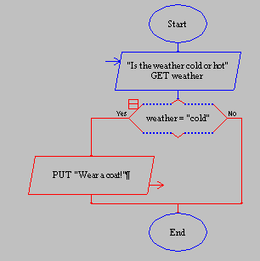
Help Video: Double click the file to view video
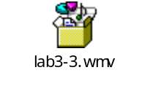

This lab requires you to convert your pseudocode in Lab 3.2 to a flowchart. Use an application such as Raptor or Visio.

Step 1: Start Raptor and save your document as Lab 3-3. The .rap file extension will be added automatically. Start by adding a Comment box that declares your variables. Here is how your Comment box should look.
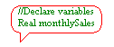
Step 2: The next step in your flowchart should be to call your methods. Below is a start of how your main should look.

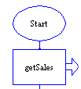

Step 3: Continue this process to add your additional methods you defined in Lab 3.2, Step 3.

Step 4: Click on the getSales tab and add the necessary code to enter the monthly sales. Your getSales method might look like the following:
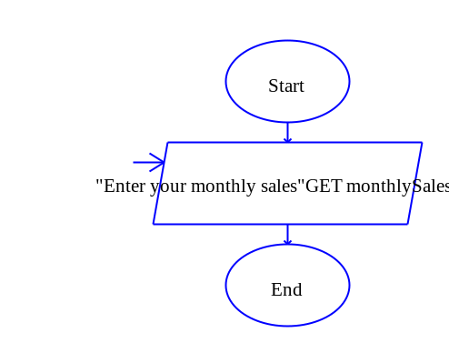
Step 5: Click on the second module which determines if a bonus of $5000 is awarded. Click the Selection symbol and add it between the start and the end of the module. Double click on the diamond symbol and add the code to determine if monthlySales is greater than or equal to 100000. The enter selection condition should be written as follows:

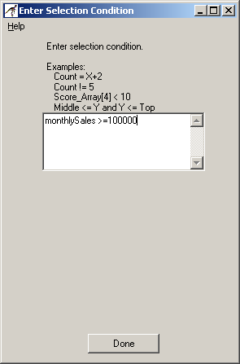

Step 6: Drag an output symbol and drop it on the True line. Double click on the output box and add text that prints “You earned a $5000 bonus!”. Your module should like as follows:
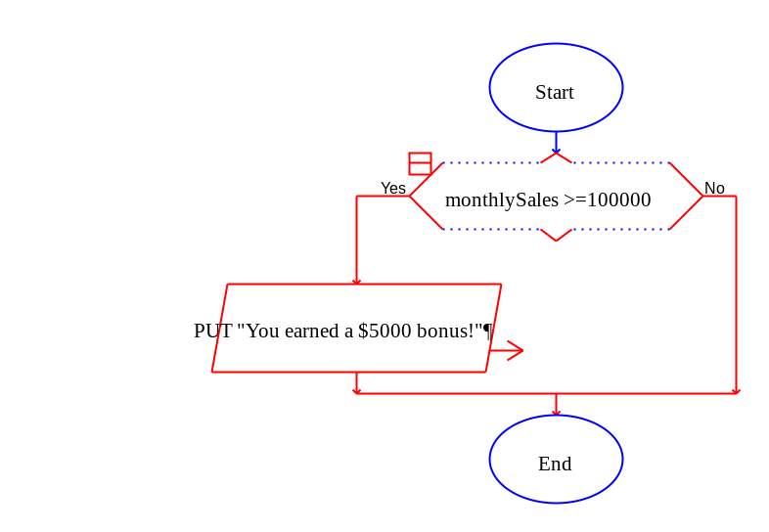
Step 7: Repeat the process in Step 6 to code your next module.

Step 8: When your program is complete, test the following monthly sales and ensure that the output matches the following. If your output is different, then review your decision statements.

Monthly Sales | Expected Output
monthlySales = 102500 | You earned a $5000 bonus!
monthlySales = 90000 | <nothing>
monthlySales= 112500 | You earned a $5000 bonus!  All employees get one day off!!!

Step 9: The final step is to insert your finished flowchart in the space below. Inside Raptor, select File and the Print to Clipboard from the menu. Inside Word in the space below, select Edit and Paste. You will have to do this for each module you created.

PASTE FLOWCHART HERE

main()

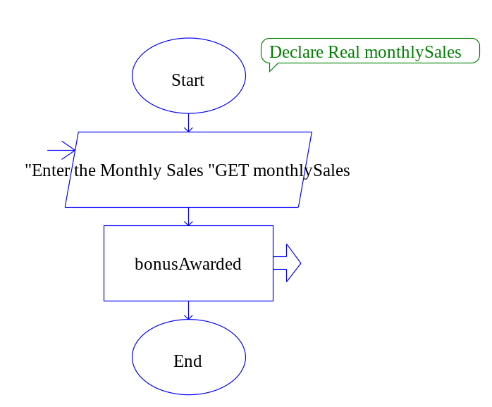

bonusAwwarded(montlySales)
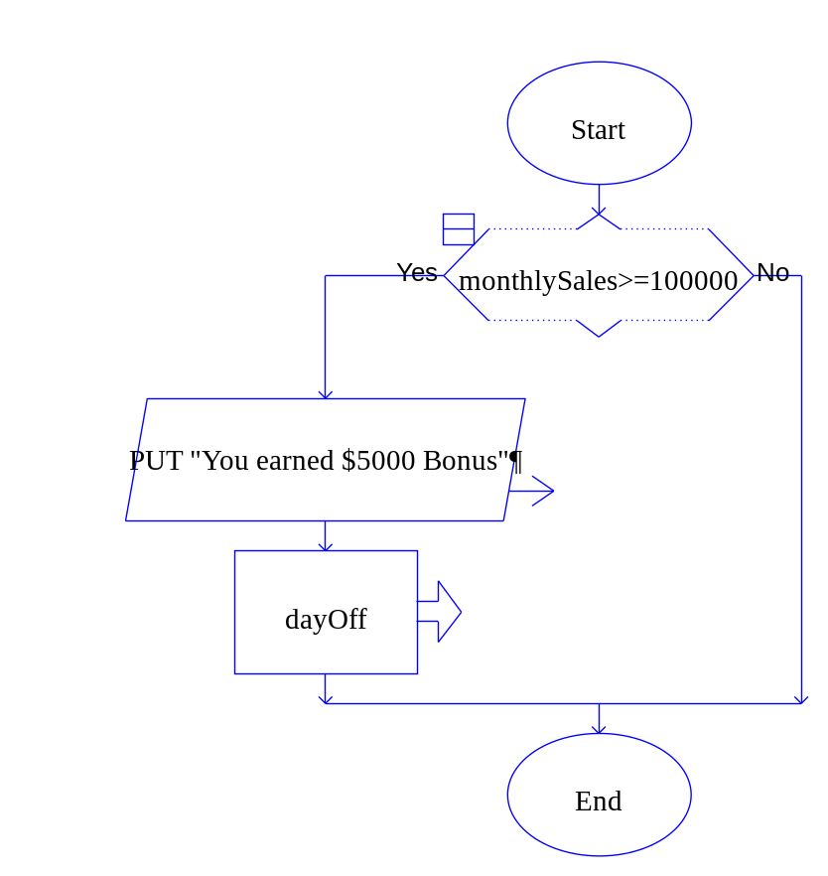
dayOff(monthlySales)
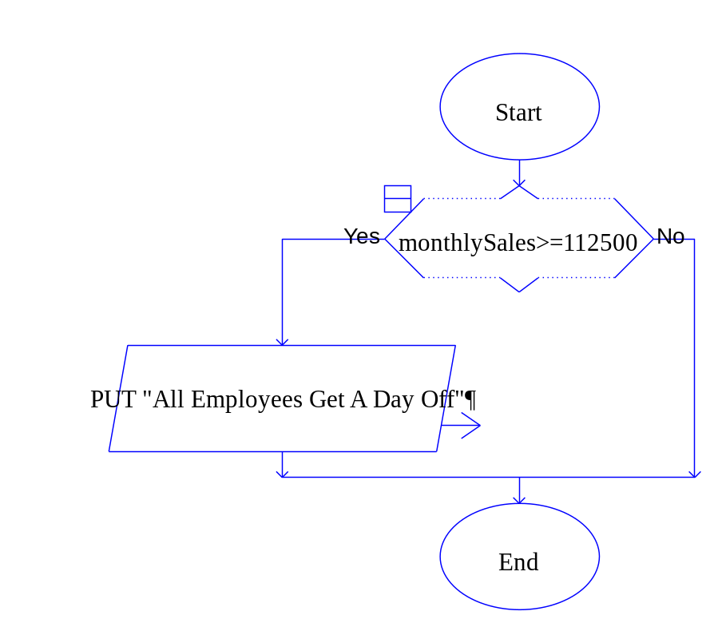

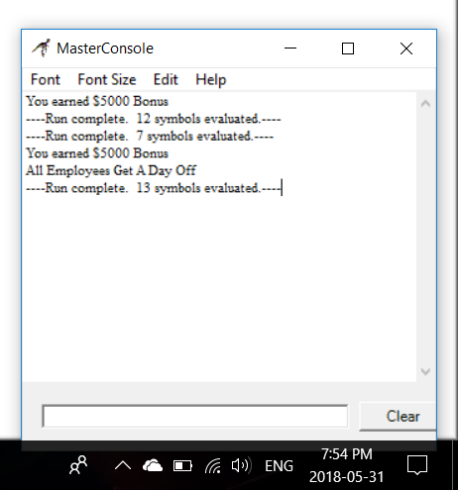
Lab 3.4 – Python Code
Critical Review

In Python we use the if statement to write a single alternative decision structure. Here is the general format of the if statement:

if condition:
statement
statement
etc.

For simplicity, we will refer to the first line as the if clause. The if clause begins with the word if, followed by a condition, which is an expression that will be evaluated as either true or false. A colon appears after the condition. Beginning at the next line is a block of statements.

When the if statement executes, the condition is tested. If the condition is true, the statements that appear in the block following the if clause are executed. If the condition is false, the statements in the block are skipped.

When strings are evaluated in a condition, single quotation marks are used. For example:

name1 = 'Mary'
name2 = 'Mark'

if name1 != name2:
print 'The names are not the same.'

if name1 == ‘Mary’
print ‘The name is Mary.’

Help Video: Double click the file to view video

Step 1: Start the IDLE Environment for Python. Prior to entering code, save your file by clicking on File and then Save. Select your location and save this file as Lab3-4.py. Be sure to include the .py extension.

Step 2: Document the first few lines of your program to include your name, the date, and a brief description of what the program does. Description of the program should be:
#This program will demonstrate how to use decision
#statements in Python.

Step 3: Start your program with the following code:

#This program determines if a bonus should be awarded

#The main function
def main():
print 'Welcome to the program'
monthlySales = getSales() # gets sales

#This function gets the monthly sales
def getSales():
monthlySales = input('Enter the monthly sales $')
monthlySales = float(monthlySales)
return monthlySales

#calls main
main()

Step 4: Add a function call to the method that determines if a bonus is awarded. The call should be in main and process after monthlySales = getSales(). Be sure to pass monthlySales to the function as an argument since that will be needed to determine if a bonus is awarded. Your code might look as follows:

#Function call to determine bonus
isBonus(monthlySales)

Step 5: Under the getSales() function, code the function that will determine if a bonus is awarded. Be sure to accept monthlySales in the parameter list. Also, note that the if statement is followed by a colon, and the print statement inside must be tabbed over.

def isBonus(monthlySales):
if monthlySales >= 100000:
print "You have earned a $5,000 bonus!!!"

Step 6: Repeat the process in Step 4 to make a function call to the method that determines if all employees get a day off.

Step 7: Repeat the process in Step 5 to code the function that will determine if all employees should get a day off.

Step 8: Click Run and Run Module to see how your program processes. Test the following monthlySales values to verify the expected output.

Monthly Sales | Expected Output
monthlySales = 102500 | You earned a $5000 bonus!
monthlySales = 90000 | <nothing>
monthlySales= 112500 | You earned a $5000 bonus!  All employees get one day off!!!

Step 9: Execute your program so that it works and paste the final code below

PASTE CODE HERE

'''
Name : Joy Chudasama
Date : 31st May,2018
Description : This program will demonstrate hpw to use decision statements in Python.
This program determines if a bonus should be awarded.
'''
def main():
print("\n\t\t\t************************")
print("\t\t\t\t\tWelcome")
print("\t\t\t************************")
global monthlySales
monthlySales=int(input("\nEnter the Monthly Sales :"))
bonusAwarded(monthlySales)
def bonusAwarded(monthlySales):
if monthlySales>=100000:
print("\n\t\t\t\tCongratulations ")
print("\n--> You Earned $5000 Bonus.")
dayOff(monthlySales)
else:
print("")
def dayOff(monthlySales):
if monthlySales>=112500:
print("\n--> All Employees Get A Day Off")
else:
print("")
main()

Lab 3.5 – Programming Challenge 1 – Guess the Secrets

Write the Pseudocode, Flowchart, and Python code for the following programming problem.

Help Video: Double click the file to view video

Guess the Secrets

Write a program that will ask the user to enter a person’s age, their weight, and their birth month. Your program will compare the entered values to the following and print the appropriate responses. Be sure to use modules.

The Secret Answers | The Comparison | The Printed Response
age = 25 | If the guessed age is less than or equal to 25 | Congratulations, the age is 25 or less
weight = 128 | If the guessed weight is greater than or equal to 128 | Congratulations, the weight is 128 or more
birthMonth = ‘April’ | If the guessed birth month is equal to April | Congratulations, the birth month is April

Hint: This program can be written a few different ways. It is suggested that only three variables are used to store the guessed answers to age, weight, and birthMonth. The pseudocode for main might look as follows:

Module main ()
//Declare local variables
Declare Integer age
Declare Integer weight
Declare String birthMonth

//Function calls
Call getAge(age)
Call getWeight(weight)
Call getMonth(birthMonth)
Call correctAnswers(age, weight, birthMonth)
End Module

If the program is written properly, sample output should look as follows:

Sample 1:
//Input
Enter your guess for age: 20
Enter your guess for weight: 140
Enter your guess for birth month: March

//Output
Congratulations, the age is 25 or less.
Congratulations, the weight is 128 or more.

Sample 2:
//Input
Enter your guess for age: 32
Enter your guess for weight: 119
Enter your guess for birth month: April

//Output
Congratulations, the birth month is April.

Sample 3:
//Input
Enter your guess for age: 58
Enter your guess for weight: 128
Enter your guess for birth month: January

//Output
Congratulations, the weight is 128 or more.

The Pseudocode

TYPE PSEUDOCODE HERE

Module main()
Declare Real age
Declare Real weight
Declare String month

Call inputData()
Call getAge (age)
Call getWeight(weight)
Call getBirthMonth(month)
End Module

Module inputData():
Global age
Global weight
Global month

Display(“Enter your guess for age”)
Input age
Display(“Enter your guess for weight”)
Input weight
Display(“Enter your guess for Birthday month”)
Input month
End Module

Module getAge(Real Age)
If age <= 25 Then
Print ”Congratulations!!!The Age is 25 or Less”
End If
End Module

Module getWeight(Real Weight)
If weight >= 128 Then
Print ”Congratulations!!!The Weight is 128 or More ”
End If
End Module

Module getBirthMonth(String Month)
If month == “April” Then
Print ”Congratulations!!!The Bithday Month Is April”
End If
End Module

The Flowchart

PASTE FLOWCHART HERE

main()
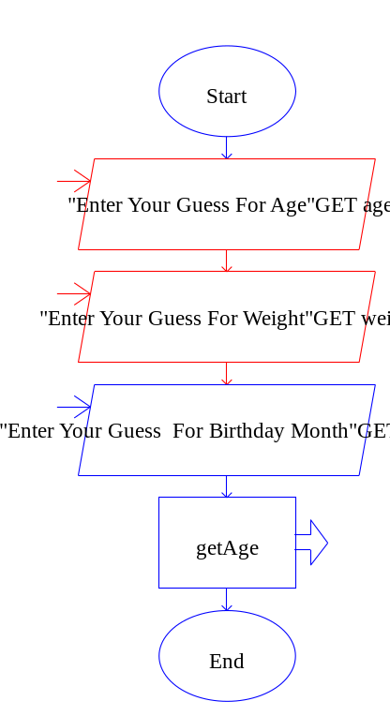
getAge ()
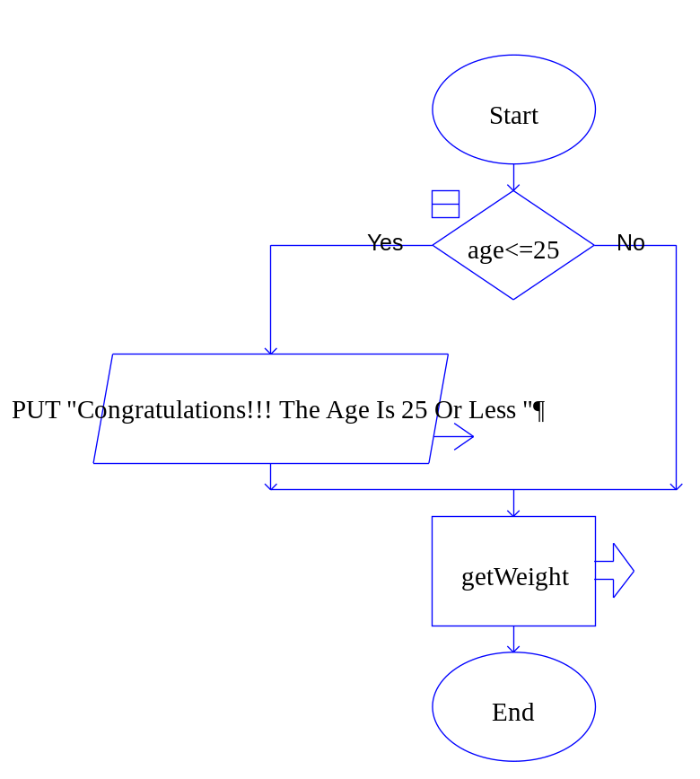

getWeight ()

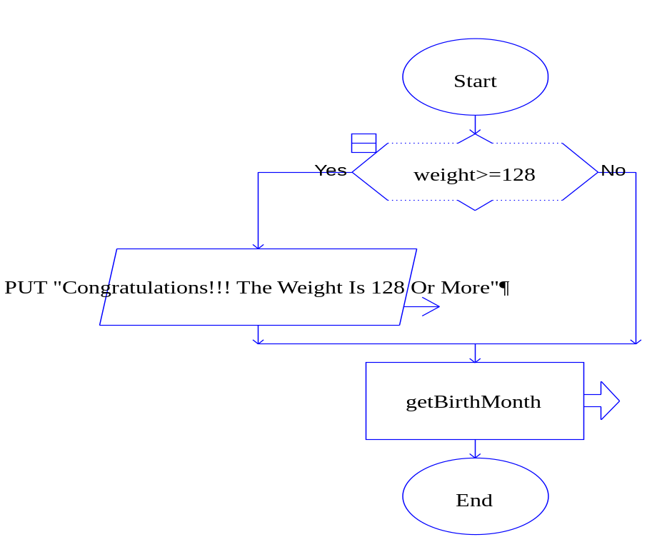

getBirthMonth ()

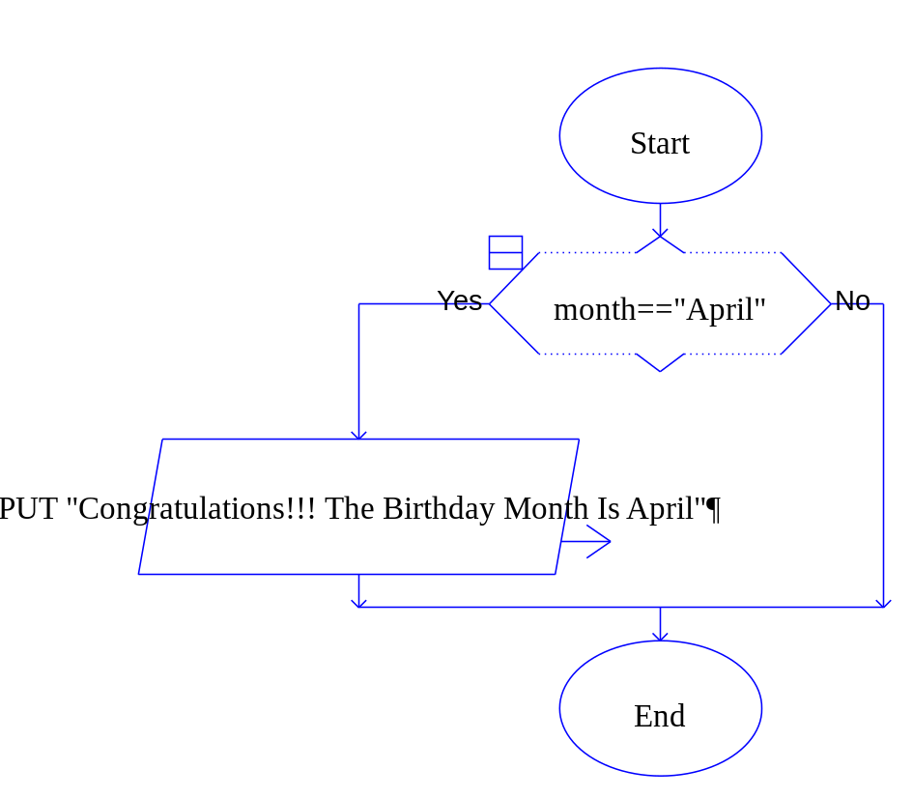

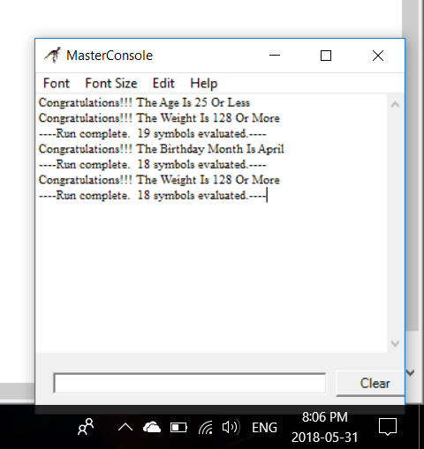

The Python Code

PASTE CODE HERE

def main():
print("\n\t\t\t\t\tWelcome To GUESS THE SECRET")
inputData()
getAge(age)
getWeight(weight)
getBirthMonth(month)
def inputData():
global age
global weight
global month
age=int(input("\nEnter Your Guess For Age :"))
weight=int(input("Enter Your Guess For Weight :"))
month=input("Enter Your Guess For Month :")
def getAge(age):
if age<=25:
print("\nCongratulations!!! The Age is 25 Or Less")
else:
print("")
def getWeight(weight):
if weight>=128:
print("\nCongratulations!!! The Weight Is 128 Or More")
else:
print("")
def getBirthMonth(month):
if month=="April":
print("\nCongratulations!!! The Birthday Month Is April")
else:
print("")
main()

